The *n*-queens puzzle is the problem of placing *n* queens on an *n*×*n* chessboard such that no two queens attack each other.

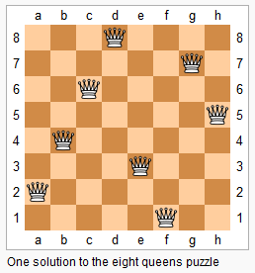

Given an integer *n*, return the number of distinct solutions to the *n*-queens puzzle.

**Example:**

**Input:** 4

**Output:** 2

**Explanation:** There are two distinct solutions to the 4-queens puzzle as shown below.

[

 [".Q..",  // Solution 1

  "...Q",

  "Q...",

  "..Q."],

 ["..Q.",  // Solution 2

  "Q...",

  "...Q",

  ".Q.."]

]